AWS Assignment
Customer Management System:
Done by: Vidhi Kapadia

1.List Customer
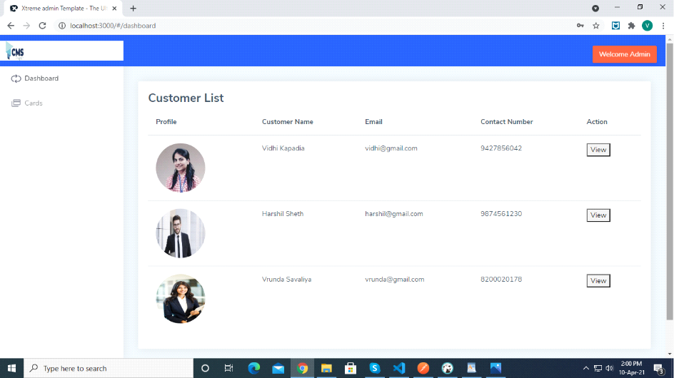
Fig:1.1 List Customer

2. Add Customer
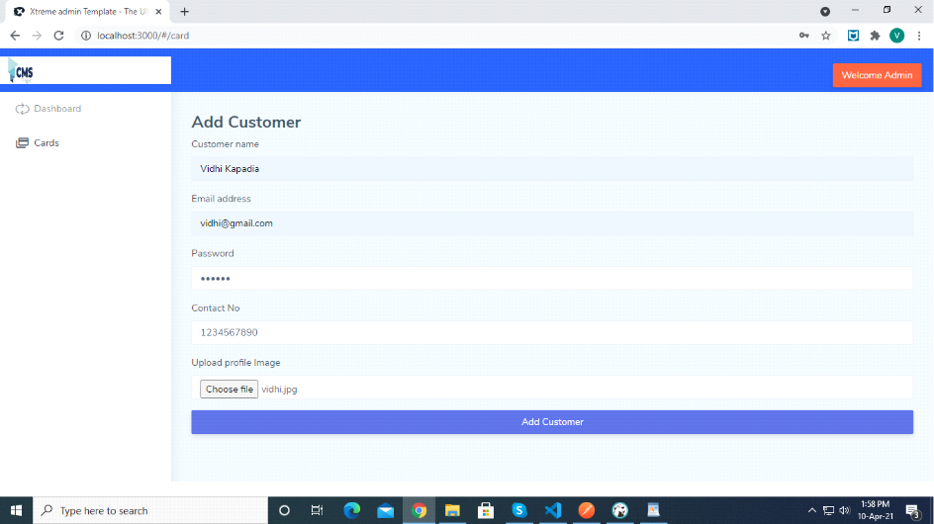
Fig:1.2 Add Customer

3. View Customer by id
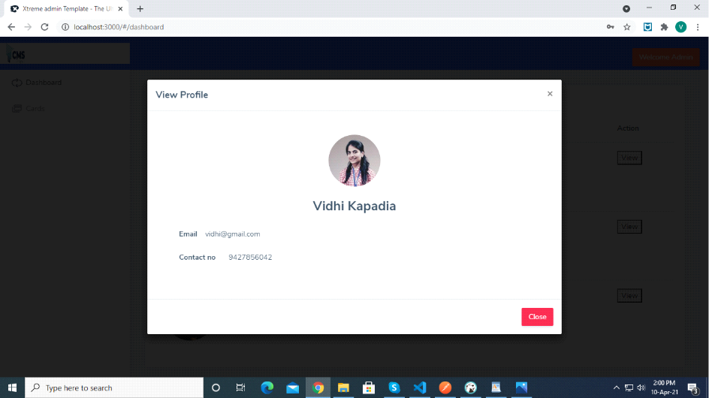
Fig:1.3 View Customer by id

